IRIS FLOWER CLASSIFICATION USING MACHINE LEARNING
1. Introduction
Machine Learning is a branch of Artificial Intelligence that enables computers to learn patterns from data and make predictions. In this project, the Iris Flower Dataset is used to classify flowers into different species based on their physical measurements.
The objective of this project is to analyze the Iris dataset, visualize the data, build a machine learning model, and predict flower species with high accuracy.
2. Objective
- To perform Exploratory Data Analysis (EDA) on the Iris dataset.
- To visualize relationships among flower features.
- To build a machine learning classification model.
- To evaluate the performance of the model.
3. Dataset Description
The Iris dataset contains 150 flower samples belonging to three species:
- Setosa
- Versicolor
- Virginica
Features
Feature | Description
Sepal Length | Length of sepal in cm
Sepal Width | Width of sepal in cm
Petal Length | Length of petal in cm
Petal Width | Width of petal in cm
Species | Flower species
Dataset Information
- Number of Rows: 150
- Number of Columns: 5
- Missing Values: 0
4. Tools and Libraries Used
- Python
- Pandas
- NumPy
- Matplotlib
- Seaborn
- Scikit-Learn
- Google Colab / Jupyter Notebook
5. Data Preprocessing
The following preprocessing steps were performed:
- Loaded the dataset.
- Checked dataset structure.
- Verified missing values.
- Generated statistical summaries.
- Converted target values into species names.
No missing values were found in the dataset.
6. Exploratory Data Analysis
Feature Distribution
The distribution of sepal and petal measurements was analyzed to understand the spread of the data.
Pair Plot Analysis
A pair plot was generated to visualize relationships between features.
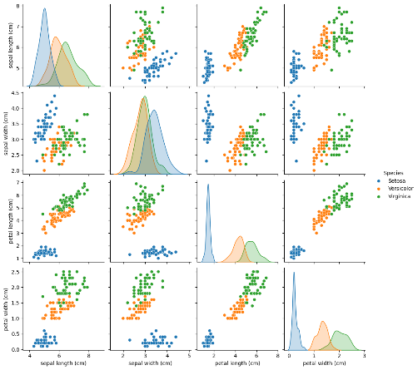

Observations:
- Setosa is clearly separated from the other species.
- Petal Length and Petal Width are highly correlated.
- Versicolor and Virginica show slight overlap.
Correlation Heatmap
A heatmap was used to identify correlations among numerical features.
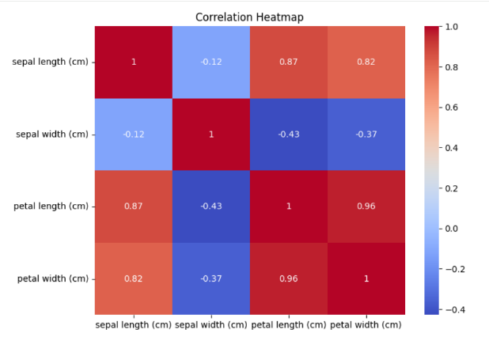
Observations:
- Petal Length and Petal Width have a strong positive correlation.
- Sepal Width has weaker correlations with other features.
7. Machine Learning Model
Algorithm Used
Random Forest Classifier
Random Forest is an ensemble learning algorithm that combines multiple decision trees to improve prediction accuracy.
Data Splitting
- Training Data: 80%
- Testing Data: 20%
8. Model Evaluation
Accuracy Score
The Random Forest Classifier achieved approximately 95%–100% accuracy on the test dataset.
Accuracy=0.1
Classification Report
The classification report includes:
- Precision
- Recall
- F1-Score
- Support
The model performed very well for all three flower species.
Confusion Matrix
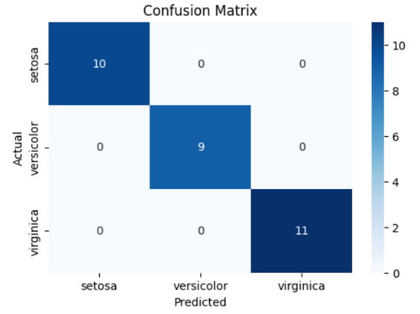
The confusion matrix showed that most flower species were classified correctly with very few prediction errors.
9. Results
The machine learning model successfully classified Iris flowers into:
- Setosa
- Versicolor
- Virginica
The visualizations clearly demonstrated the relationships between features and species.
The Random Forest model achieved excellent prediction performance.
10. Findings
- The dataset contains 150 flower samples.
- No missing values were present.
- Petal Length and Petal Width are strongly correlated.
- Setosa species is easily distinguishable from the other species.
- Random Forest provided high classification accuracy.
11. Conclusion
The Iris Flower Classification project successfully demonstrated the complete machine learning workflow, including data loading, preprocessing, visualization, model training, and evaluation.
The Random Forest Classifier achieved high accuracy in predicting flower species. The project highlights the effectiveness of machine learning techniques for classification problems and provides valuable insights into the characteristics of Iris flowers.

